**Krutidev** and **Unicode** are both character encoding systems used to represent text, but they are quite different in their scope, usage, and compatibility.

**Krutidev**

* **What it is**: Krutidev is a legacy font used primarily for typing in Hindi, specifically in the Devanagari script.
* **Usage**: It is widely used in older documents, especially in governmental and educational institutions in India.
* **Encoding**: Krutidev is not a standard encoding system; it is a font-based encoding. Each character in the Krutidev font is mapped to a specific character code in the ASCII range, but these codes do not correspond to the Unicode standard.
* **Compatibility**: Since Krutidev is font-based, it works only if the Krutidev font is installed on the system. If the font is not available, the text appears as meaningless characters.
* **Conversion**: Converting Krutidev text to Unicode can be challenging because it requires mapping each font-specific character to its corresponding Unicode character.

**Unicode**

* **What it is**: Unicode is a universal character encoding standard that aims to support all the world's writing systems.
* **Usage**: It is used globally across various platforms, applications, and systems. Unicode has become the standard for modern text encoding, ensuring that text can be consistently represented and read across different devices and applications.
* **Encoding**: Unicode provides a unique code point for every character, no matter what the platform, program, or language. For example, the Devanagari script used in Hindi has a specific range of Unicode code points.
* **Compatibility**: Unicode is supported by all modern operating systems, browsers, and applications. This ensures that text encoded in Unicode can be displayed correctly on any device that supports Unicode.
* **Conversion**: Since Unicode is a standardized system, converting text between different Unicode encodings (like UTF-8, UTF-16) is straightforward and well-supported.

**Key Differences**

1. **Scope and Standardization**:
   * **Krutidev**: Limited to specific fonts and not standardized.
   * **Unicode**: A comprehensive, globally accepted standard.
2. **Compatibility**:
   * **Krutidev**: Dependent on the availability of the specific font.
   * **Unicode**: Universally compatible across different systems and applications.
3. **Usage**:
   * **Krutidev**: Primarily used for typing Hindi in older documents and systems.
   * **Unicode**: Used for representing text in any language and script in modern systems.
4. **Conversion**:
   * **Krutidev**: Requires specialized tools to convert to Unicode.
   * **Unicode**: Conversion between different Unicode encodings is simple and supported by many tools.

**Example of krutidev: vHfk"ksd cUnsokj**: This translates to Abhishek Bandhevar in plain text.

When you convert Krutidev to Unicode you get the following text in Devanagari script: **अभिषेक बन्देवार.**

The logic behind using the app:

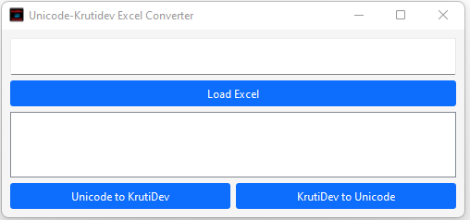

**Step-by-Step Logic for Conversion:**

Let's outline the steps for converting from Krutidev to Unicode and vice versa:

**Krutidev to Unicode Conversion:**

**1. Load the Excel File:**

- Read the content of the selected Excel file.

**2. Identify Selected Columns:**

- Identify which columns are checked for conversion (in this case, "STUDENT NAME H").

**3. Read Column Data:**

- Extract the data from the selected columns.

**4. Conversion Logic:**

- For each cell in the selected column:

- Use a predefined mapping or a conversion library/tool to translate each Krutidev character to its corresponding Unicode character.

**5. Replace Column Data:**

- Replace the original Krutidev text with the newly converted Unicode text in the same column.

**6. Save the Modified Excel File:**

- Save the changes to a new Excel file or overwrite the existing one.

**Unicode to Krutidev Conversion:**

**1. Load the Excel File:**

- Read the content of the selected Excel file.

**2. Identify Selected Columns:**

- Identify which columns are checked for conversion.

**3. Read Column Data:**

- Extract the data from the selected columns.

**4. Conversion Logic:**

- For each cell in the selected column:

- Use a predefined mapping or a conversion library/tool to translate each Unicode character to its corresponding Krutidev character.

**5. Replace Column Data:**

- Replace the original Unicode text with the newly converted Krutidev text in the same column.

**6. Save the Modified Excel File:**

- Save the changes to a new Excel file or overwrite the existing one.

**System Configuration used for testing:**

* OS Name: Microsoft Windows 11 Pro
* Installed Physical Memory (RAM): 8.00 GB

**Testing:**

* Opened the app and chose the file to be converted.
* Selected the STUDENT NAME H column which consists of krutidev format text for conversion and then click on the “Krutidev to Unicode” button, this generates a new file with the converted text.

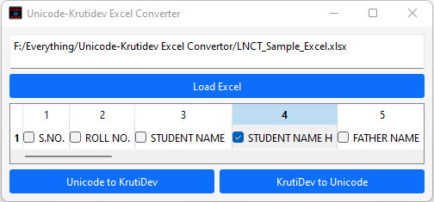

* The original file where the STUDENT NAME H column is in krutidev as we can see in the image below:

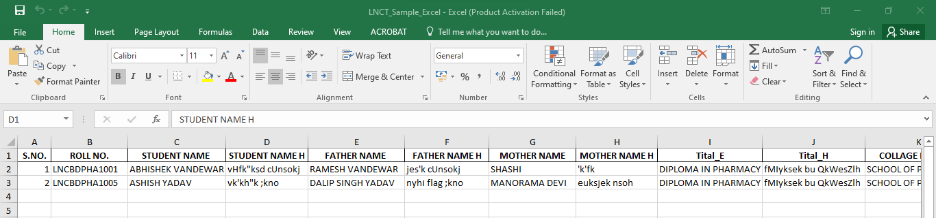

* The Converted file with the STUDENT NAME H column converted to Unicode, as we can see in the image below:

